VILLAGE OF WARRENSBURG
BOARD OF TRUSTEES
& ASSIGNED COMMITTEE
Mayor: Leland Hackl
Building/Land: Brian Netherton
Finance: Christal Eskew
Police: Doug Fisher
Sewer: Scott Bons
Streets: Jarrod Krall
Water: Chase Davis
WARRRENSBURG POLICE DEPARTMENT
February  2026
Traffic:
Vehicle Stops: 37
State Citations: 23
Written Warnings: 23
Verbal Warnings: 00
Ordinance Citations: 00
Accident Reports: 01
Total Written Reports for all Offenses and Informational Reports: 6
Criminal Offense Reports and investigations: 03
- Warrant Arrest Report, Domestic Violence report, Agg Assault Report.
Traffic Safety and offense Reports: 02
- 1 Accident Reports, DWLS/DWRS Report
Juvenile offense/Victim, Lost or Found Property, Informational Reports: 01
- Informational Report
Village of Warrensburg Ordinance Violations and Animal Control reports: 00
Other Police Business, Community Events, and Training
- Several other Agency Assist: Medical Calls, Police Assist, Completed multiple Courtesy Business closing stand by, Multiple Business security checks, Several Ordinance related calls for service and investigations, Mandate Training, Animal Control Calls.

More details at: www.warrensburgil.com
Warrensburg Police Department contact info:
Non-emergency: 217.672.3611 Emergency: 911

Board Meetings are held at 5:30 pm at
Village Hall on Monday, March 2, 2026 and Monday, March 16, 2026.

Pay your water bill online at www.warrensburgil.com

The Village hours of operation are Monday-Friday, 7:30 am- 4 pm.

Warrensburg-Latham Lions club will host their Breakfast Extravaganza Saturday, March 14, 2026 at 7 am- 10 am at the Warrensburg United Methodist Church.

Friends of the Library Easter Egg Hunt March 21st at Illini Park at 10:30am

 July 16 – 18, 2026
“Festival Friends”
Your generous contribution will help ensure another A-MAIZE-ing event & help celebrate our 10th anniversary! Simply indicate your amount of support and include this with your payment. Please make checks payable to the Village of Warrensburg. THANK YOU!!

Public Works has asked that you provide the information for the Service Line Material for your residence. Lead, Galvanized, Copper, or Plastic. You can call into the Village Hall with this information. If you do not know, we can send someone out as well.

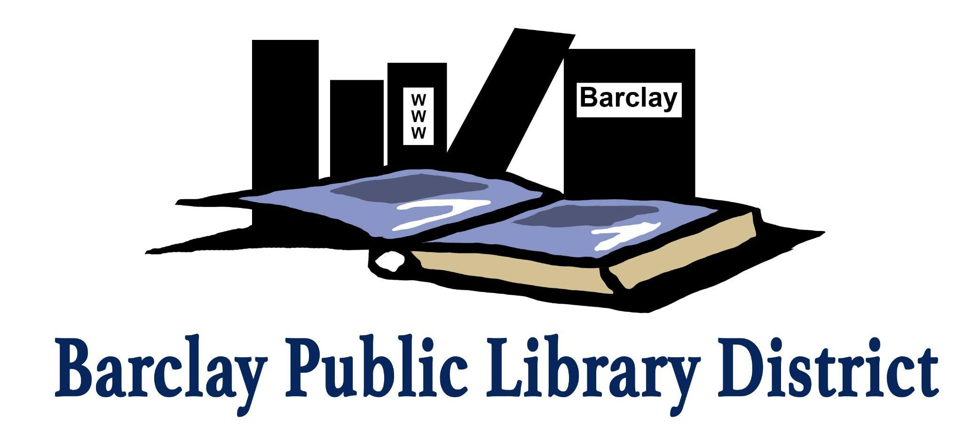
220 S. Main Warrensburg
www.barclaylibrary.org
217-672-3621
March 2026

KIDS
Storytime
Join us every Tuesday and Wednesday for a story and craft! No registration required.
*At Barclay Library, Warrensburg – Tue 10:30 AM
*At Harristown Community Center - Wed 10:30 AM

Music Makers
0-5 years old Fridays at 10:30 AM
Bring your little ones to make music each Friday! We will sing songs and play instruments! 0 – 5 years old. No registration required. Older siblings are welcome.

Kids Movie
Wednesday, March 11th at 1:30 PM
Zootopia 2
Join us for a movie on our big screen and
FREE popcorn too!

St. Patrick’s Day Program
Thursday, March 12th at 5:00 PM
Harristown Community Center
Snacks and Shenanigans for the whole family! Come and enjoy the fun!

Dr. Seuss Craft Party
Thursday, March 19th 3:30 -5:00 PM
Barclay Public Library
Stop in the library after school to make some crafts.

1,000 Books Before Kindergarten
Read with your little ones and build early literacy skills—plus earn fun prizes! Join families nationwide in the challenge to read 1,000 books before kindergarten. Children earn a certificate for every 100 books, a book buddy at 500, and a special book bag at 1,000.
Register at the library service desk.

Showcase Your Collection or Small Business
The library is now accepting display case inquiries! Whether you collect, create, or own a small business, our display case offers a two-week opportunity to share your story with the community. Contact us at director@barclay.lib.il.us or send a Facebook message to get started.

Barclay’s Sharing Shelf - Food “Pantry”
Located just inside the library entryway, Barclay’s Sharing Shelf is available during regular business hours. This is a take what you need, give what you can food pantry offering nonperishable items to support our community.

ADULTS
Crochet & Connect: Carrot Basket
Tuesday, March 3rd, 6:00-7:30 PM
Barclay Public Library
Each month, a beginner-friendly crochet pattern is provided. The focus is on getting started, learning together, and enjoying the process - not on finishing a project in one night.
Registration Required.

Beaded Plants
Thursday, March 12th, 6:00 PM
Barclay Public Library
Join us for creating a mini plant with beads.
Registration Required.
Crochet Foundations: Getting Started with Crochet
Tuesday, March 17, 6:00-7:30 PM
Harristown Community Center
This class is tailored for absolute beginners.
Registration Required.

Tea Blending
Thursday, March 26th, 6:00 PM
Harristown Community Center
Join us for a night of learning about tea ingredients
and make a sample blend to take home.
Registration Required.

Homemakers’ Swap
Saturday, March 28th, 10:00 AM
Barclay Public Library
Bring your DIY creations, homemade goods, or homesteading products to share and swap with fellow crafters and makers! Sample new treats, discover creative ideas, and take home a little something from your neighbors.
Registration Required.

BOOK CLUBS First Wednesday Book Club
Wednesday, March 4th at 10:30 AM
Pony Confidential by Christina Lynch
Second Saturday Book Club
Saturday, March 14th at 11:00 AM
Under the Tulip Tree by Michelle Shocklee

Clueminati/Third Wednesday Book Club Wednesday, March 18th at 6:00 PM A Good Girl’s Guide to Murder by Holly Jackson
SAVE THE DATE
FRIENDS OF LIBRARY Easter Egg Hunt March 21st
COOKBOOK CLUB April 18th
BOOK AND BAKE SALE April 24th and 25th
(VIP Shopping for Friends of Library April 23rd)

